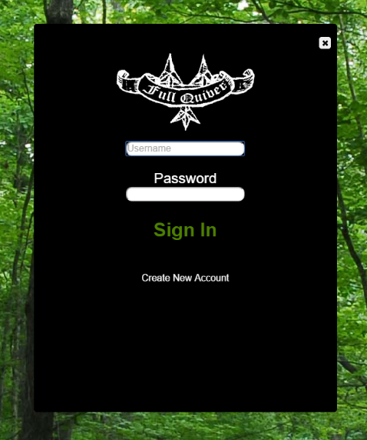

Login Page

This is the page that you will sign into your account. You will enter your username and password, then press “Sign In”. If the user does not currently have an account for **Full Quiver**, then you may create an account by clicking “Create New Account”.

Once you have successfully signed into your account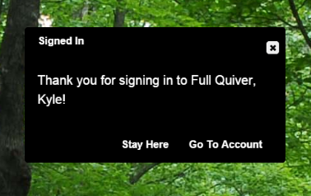 you will come to this screen. This new screen will give you the option to either stay on the page you were on when you clicked “Sign In” on the main page, or go straight to your account page.

Account Page

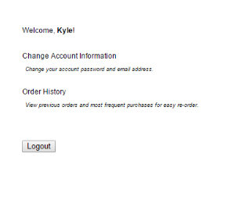

Once you visit the account page you will notice some text on the left side of the page.

You will have the option to either change your account information, view your order history or sign out of your account.

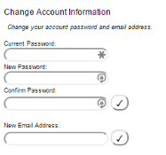If you click on “Change Account Information”, you will be able to change your password, and your email address. They have different submit buttons, so you will be able to submit them each on their own.

In order to change your password you must follow this order:

1. Enter your current password in the first textbox.
2. Enter your new desired password in the second textbox.
3. Confirm your new password in the third textbox.
4. Click the checkmark button beside the “Confirm Password” textbox.



In order to change your email you must follow this order:

1. Enter your new desired email the fourth textbox.
2. Click the checkmark button beside the “New Email Address” textbox.

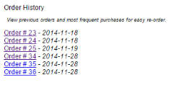

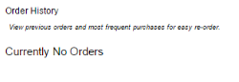You may also view your previous orders that you have placed. In order to view your previous orders you may click on “Order History”. Once you have opened the order history list you will see all of your orders. If you have no orders placed your page will look like the second image to the right.

If you would like to view one of your orders you may click the order you want to view. Once you click on one your orders the browser will open a new tab where you can view your order.

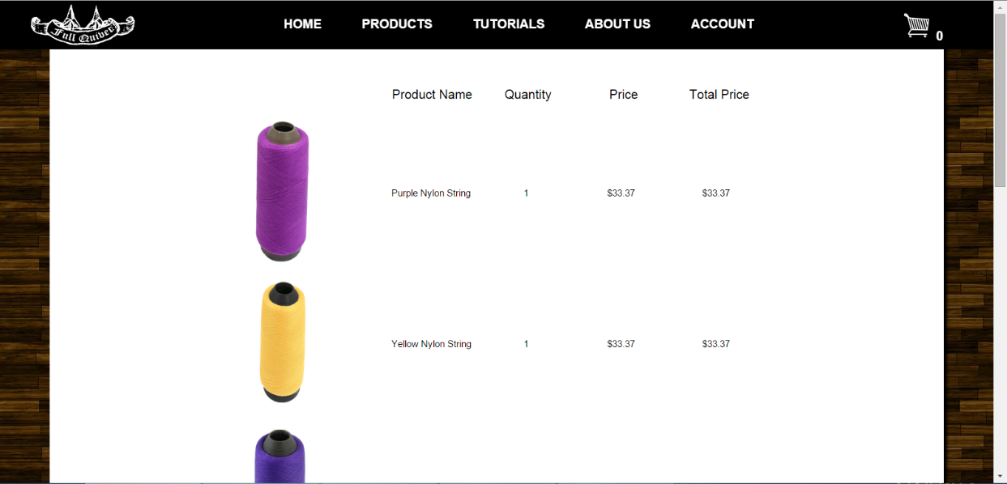

The last process you may do on your account page is sign out of your account. 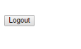

This process will log you out of your account. If you have any items in your shopping cart, they will still remain there in your shopping cart. After you sign out of your account, you will be redirected to the index page.

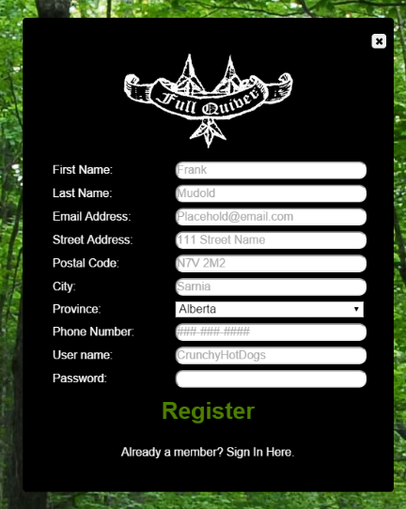

Creating An Account

This is the page that will be used for registering a new user for **Full Quiver**. You will have to fill in all of the fields in order to complete registration.

This is the order you should fill in the form:

1. First Name
2. Last Name
3. Email – Must be in the style of Email@Email.com/ca
4. Street Address
5. Postal Code – Must be in the style of A1A 1A1
6. City
7. Province
8. Phone Number – Must be in the style of ###-###-####
9. Username
10. Password

Once all of these fields are filled in, you will click “Register”. If you have any problems with the information that you entered, you will be shown a page (Figure #.#) which will outline your errors. You can click “Cancel” to return to the page you were on before, or you can click “Try Again” to go back to the previous form (Figure #.#). Once you register, the website will sign you in automatically. You will then be able to go back to your current page or go to your account page (Figure #.#).



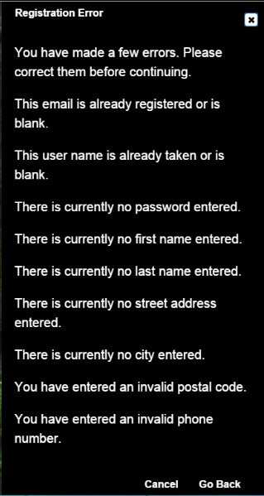

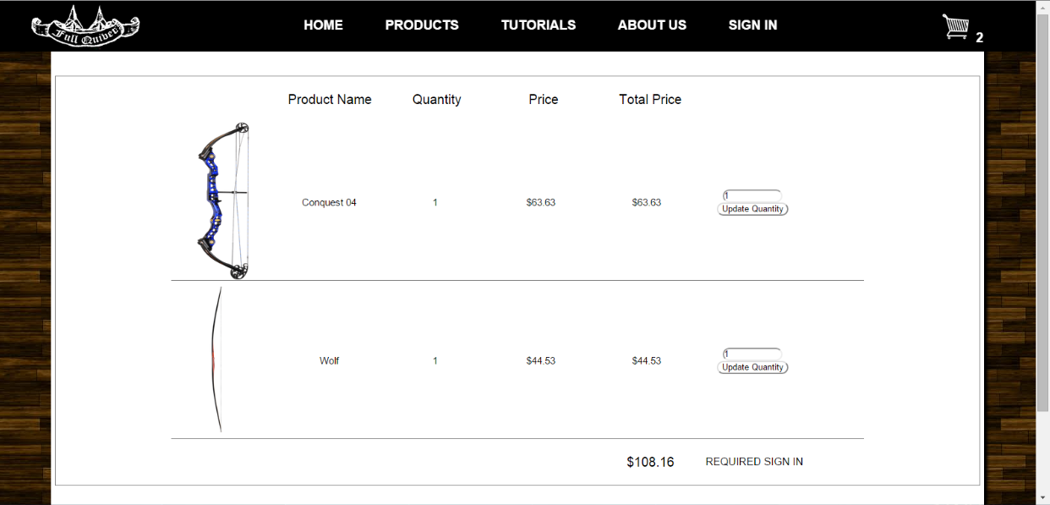

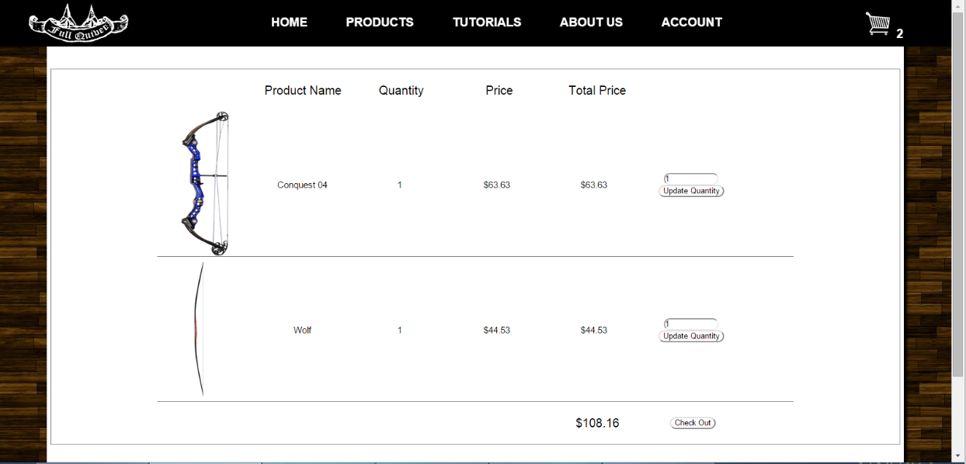

Shopping Cart

Once you have added items in your shopping cart and go to the checkout page, you will see one of these two screens. If you are signed into your account, you will see a page (Figure #.#) with a checkout button, but if you are not signed in (Figure #.#) you will be asked to log in.

Your products that you have added into the shopping cart will display in rows down the page. You can update the quantity of each object you want by changing the text box relative to the product, to the quantity you want. After you have the right quantity you need to click the “Update Quantity” button.

After you click the checkout page, your order will be placed into the database and we will start working on sending your items to you. You will have a few options once you finish your order. You will be able to continue shopping, which takes you to the products page, and the second option is to view your order.

